 | 9.1.6 Editors - UV Editor - Header - UV menu
Table of content
Detailed table of content 1
UV menu 7
Legacy 7
Transform 7
Mirror 11
Snap 12
Pin 12
Unpin 12
Invert Pins 12
Unwrap 13
Merge 18
Split Selection 19
Pack Islands 19
Average Island Scale 21
Minimize Stretch 21
Stitch 22
Mark Seam 23
Seams from Islands 24
Align/Arrange Islands 24
Set User Region 25
Align submenu 26
Move on Axis submenu 27
Copy UV 28
Paste UV 28
Show / Hide Faces submenu 28
Reset 28
Export UV Layout 28

Detailed table of content

Detailed table of content
Detailed table of content 1
UV menu 7
Legacy 7
UV Rip Move 7
Transform 7
Rotate Clockwise 90° 7
Rotate Counter Clockwise 90° 7
Last Operator Rotate 7
Angle 7
Axis 8
Orientation 8
Mirror Editing 8
Proportional editing 8
Proportional Falloff 8
Proportional Size 8
Connected 8
Projected(2D) 8
Shear 8
Last Operator Shear 8
Offset 8
Axis 8
Axis Ortho 8
Orientation 8
Mirror Editing 8
Proportional editing 9
Proportional Falloff 9
Proportional Size 9
Connected 9
Projected(2D) 9
Vertex Slide 9
Last Operator Vertex Slide 9
Factor 9
Even 9
Flipped 9
Clamp 9
Mirror Editing 9
Edge Slide 9
Last Operator Edge Slide 10
Factor 10
Even 10
Flipped 10
Clamp 10
Mirror Editing 10
Randomize 10
Last Operator Randomize 10
Random Seed 10
Randomize Location 10
Location 10
Randomize Rotation 10
Rotation 10
Randomize Scale 10
Scale Even 10
Scale 10
Mirror 11
Copy Mirrored UV coords 11
Last Operator Copy Mirrored UV Coords 11
Axis Direction 11
Precision 11
X 11
Y 11
Last Operator Mirror X Y Z Global 11
Orientation 11
Constraint Axis 11
Snap 12
Last Operator Snap Selection and Snap Cursor 12
Target 12
Pin 12
Unpin 12
Invert Pins 12
Last operator Pin 12
Clear 12
Invert 12
Unwrap 13
Angle Based 13
Conformal 13
Minimum Stretch 13
Last Operator Unwrap 13
Method 13
Method Angle based + Conformal 13
Method 13
Fill Holes 13
Use Subdivision Surface 13
Correct Aspect 13
Margin Method 13
Scaled 13
Add 13
Fraction 14
Margin 14
Method Minimum Stretch 14
Iterations 14
No Flip 14
Importance Weight 14
Use Subdivision Surface 14
Correct Aspect 14
Margin Method 14
Scaled 14
Add 14
Fraction 14
Margin 14
Smart UV Project 14
Smart UV Project Settings dialogue 14
Angle Limit 14
Margin Method 15
Scaled 15
Add 15
Fraction 15
Rotation Method 15
Island Margin 15
Area Weight 15
Correct Aspect 15
Last Operator Smart UV Project 15
Lightmap Pack 15
Settings 15
Selection 15
Share Tex Space 15
New UV Map 16
Pack Quality 16
Margin 16
Follow Active Quads 16
Settings 16
Edge Length Mode 16
Last Operator Follow Active Quads 16
Cube Projection 16
Last Operator Cube Projection 16
Cube Size 16
Correct Aspect 16
Clip to Bounds 16
Scale to Bounds 16
Cylinder Projection 16
Last Operator Cylinder Projection 17
Direction 17
Align 17
Pole 17
Preserve Seams 17
Radius 17
Correct Aspect 17
Clip to Bounds 17
Scale to Bounds 17
Sphere Projection 17
Last Operator Sphere Projection 17
Direction 17
Align 17
Pole 17
Preserve Seams 17
Correct Aspect 18
Clip to Bounds 18
Scale to Bounds 18
Merge 18
At Center 18
At Cursor 18
Last Operator Snap Selection 18
Target 18
By Distance 18
Last Operator Merge UV's by Distance 18
Merge Distance 18
Unselected 18
Shared Vertex 18
Split Selection 19
Pack Islands 19
Pack Islands Popup 19
Shape Method 19
Exact Shape (Concave) 19
Boundary Shape (Convex) 19
Bounding Box 19
Scale 19
Rotate 19
Rotation Method 19
Any 19
Cardinal 20
Axis - aligned 20
Axis - aligned ( Horizontal ) 20
Axis - aligned ( Vertical ) 20
Margin 20
Margin Method 20
Scaled 20
Add 20
Fraction 20
Lock Pinned Islands 20
Lock Method 20
Scale 20
Rotation 20
Rotation and Scale 20
All 20
Merge Overlapping 20
Pack To 21
Closest Udim 21
Active Udim 21
Original Bounding Box 21
Custom Region 21
Average Island Scale 21
Minimize Stretch 21
Last Operator Minimize Stretch 22
Fill Holes 22
Blend 22
Iterations 22
Stitch 22
Last Operator Stitch 23
Use Limit 23
Snap Island 23
Limit 23
Static Island 23
Active Object 23
Snap at Midpoint 23
Clear Seams 23
Operation Mode 23
Mark Seam 23
Last Operator Mark Seam 24
Clear 24
Clear Seam 24
Seams from Islands 24
Align/Arrange Islands 24
Last Operator Arrange/Align Islands 24
Initial Position 24
Bounding Box 24
UV Grid 24
Active UDIM 24
2D Cursor 25
Axis 25
Align 25
Min 25
Center 25
Max 25
None 25
Order 25
Margin 25
Value 25
Set User Region 25
Use 26
Align submenu 26
Straighten 26
Straighten X 26
Straighten Y 26
Align Auto 26
Align X 26
Align Y 27
Last operator Align 27
Axis 27
Align Rotation 27
Last operator Align Rotation 27
Method 27
Geometry 27
Edge 27
Auto 27
Move on Axis submenu 27
Dynamic 27
Pixel 27
UDIM 27
Copy UV 28
Paste UV 28
Show / Hide Faces submenu 28
Reveal Hidden 28
Hide Selected 28
Hide Unselected 28
Last Operator Reveal Hidden / Hide Selected 28
Select 28
Reset 28
Export UV Layout 28
All UV's 28
Export Tiles 29
Modified 29
Format 29
Size 29
Fill Opacity 29

UV menu
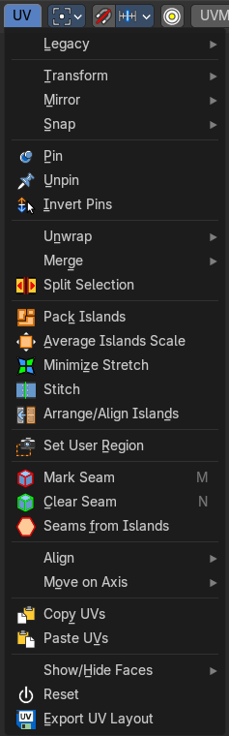
The UV header menu contains all the UV related operators in the UV Editor.

Legacy

UV Rip Move
This “cuts” the selection from the island so you can then move it. This can also be accessed by the modal operator in the tool shelf.

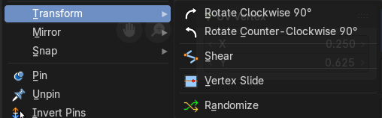
Transform

Rotate Clockwise 90°
Rotates the selection by 90 degree clockwise.

Rotate Counter Clockwise 90°
Rotates the selection by 90 degree counter clockwise.

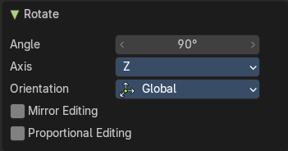
Last Operator Rotate

Angle
The rotation angle.

Axis
Defines one axis of the imaginary shear axis plane.

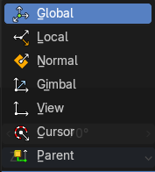
Orientation
Choose the orientation for the shear action.

Mirror Editing
Enable mirror editing.

Proportional editing
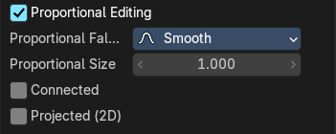
Enables proportional editing. Activating proportional editing reveals further settings.

Proportional Falloff
Adjust the falloff methods.

Proportional Size
See and adjust the falloff radius.

Connected
The proportional falloff gets calculated for connected parts only.

Projected(2D)
The proportional falloff gets calculated in the screen space. Depth doesn't play a role. When it's in the radius, then it gets calculated.

Shear
Shear shears the selection.

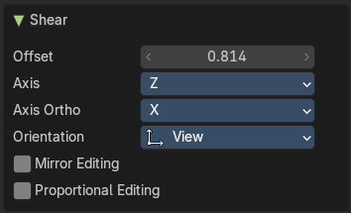
Last Operator Shear

Offset
Adjust an offset.

Axis
Defines one axis of the imaginary shear axis plane.

Axis Ortho
Defines the other axis of the imaginary shear axis plane.

Orientation
Choose the orientation for the shear action.

Mirror Editing
Enable mirror editing.

Proportional editing
Enables proportional editing. Activating proportional editing reveals further settings.

Proportional Falloff
Adjust the falloff methods.

Proportional Size
See and adjust the falloff radius.

Connected
The proportional falloff gets calculated for connected parts only.

Projected(2D)
The proportional falloff gets calculated in the screen space. Depth doesn't play a role. When it's in the radius, then it gets calculated.

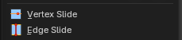
Vertex Slide
Slide a vertex along the parent edge of the mesh UV.
Note: This is exclusively a vertex selection mode operator.

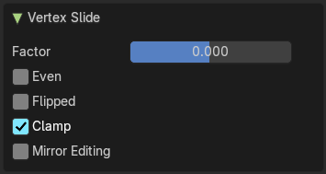
Last Operator Vertex Slide

Factor
The factor of the slide, moving the selection in a positive or negative direction from starting position.

Even
Make the edge loop match the shape of the adjacent edge loop.

Flipped
When Even mode is active, this will flip between the two adjacent edge loops

Clamp
Clamp within the edge constraints.

Mirror Editing
Edit it in mirror mode.

Edge Slide
Slide an edge along the adjacent edges of the mesh UV.
Note: This is exclusively an edge selection mode operator.

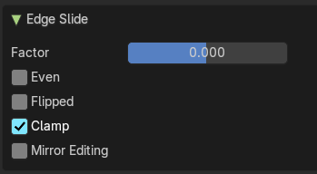
Last Operator Edge Slide

Factor
The factor of the slide, moving the selection in a positive or negative direction from starting position.

Even
Make the edge loop match the shape of the adjacent edge loop.

Flipped
When Even mode is active, this will flip between the two adjacent edge loops

Clamp
Clamp within the edge constraints.

Mirror Editing
Edit it in mirror mode.

Randomize

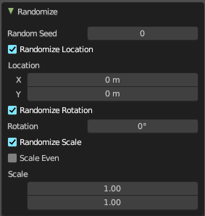
Last Operator Randomize

Random Seed
The seed for the randomization.

Randomize Location
Randomize the location values.

Location
The maximum distance the objects can spread over each axis.

Randomize Rotation
Randomize the rotation values.

Rotation
The maximum allowed rotation

Randomize Scale
Randomize the scale values.

Scale Even
Randomize the scale values.

Scale
The maximum scale the objects can scale over each axis.

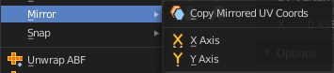
Mirror

Copy Mirrored UV coords
Copies and pastes the selected UV geometry on the X axis based on a mirrored mesh.
Use UV Select Sync must be off. The tool does not work with Use UV Select Sync on. And it is not fully reliable as our example shows.

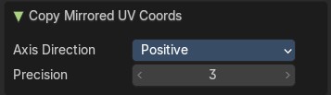
Last Operator Copy Mirrored UV Coords

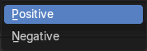
Axis Direction
The axis direction.

Precision
Tolerance for finding vertex duplicates.

X
Mirrors the selection in X axis. The mirror point is the pivot of the selection.

Y
Mirrors the selection in Y axis. The mirror point is the pivot of the selection.

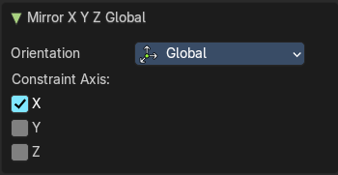
Last Operator Mirror X Y Z Global
The Last Operator Mirror panel gives you tools to adjust the mirror action.

Orientation
Orientation is a drop-down box to choose the type of orientation for the mirroring action.

Constraint Axis
Constraint Axis gives you the possibility to define the mirror axis. You can choose more than one axis here.

Snap
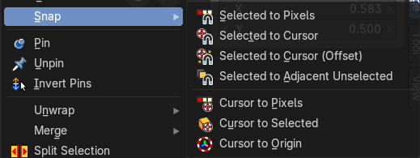
Snap is a sub menu with some snapping tools. The menu items should be pretty self explaining. Selected to Pixels snaps the selected geometry to the pixels of the image, and so on.

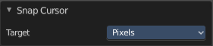
Last Operator Snap Selection and Snap Cursor

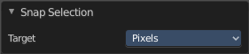
Target
Set the snap target method again.

Pin
Pins the selected vertices . This vertices are now nailed for the unwrap algorithms Angle based and Conformal. Their positions will not change when you repeat the unwrapping. And the algorithms will try to fit the rest of the geometry to this pinned vertices.
Pinned vertices are marked red.
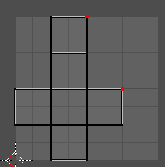
A use case is for example when you have a distorted result for symmetric geometry like a face with the Conformal method. Then you can try to align two center vertices, pin them, and repeat the conformal method. It may be more symmetrical afterwards.

Unpin
Unpins pinned geometry.

Invert Pins
This operator inverts the pins to all selected pins, and unpins the set pins. This will only work if you have geometry selected.

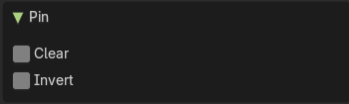
Last operator Pin
This last operator appears in the 3D view to the bottom left of the editor. Pin, Unpin and Invert Pins shares the same last operator.

Clear
Unpins pinned geometry.

Invert
Inverts the pinned geometry to selected geometry, and unpins the set pins.

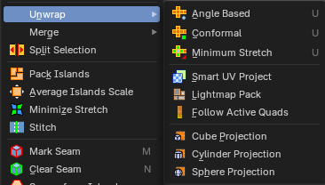
Unwrap

Angle Based
Unwraps the selected geometry with the method Angle based. ABF stands for Angle Based Flattening. ABF can give a bit better result than LSCM when unwrapping organic shapes.

Conformal
Unwraps the selected geometry with the method LSCM, which is the short for Least Square Conformal Mapping. LSCM can give a bit better results than ABF with geometric shapes.

Minimum Stretch
Unwraps the selected geometry with the method SLIM, which is a “state-of-the-art” iterative UV unwrapping algorithm.

Last Operator Unwrap

Method
Method is a drop down box where you can choose the unwrap method.

Method Angle based + Conformal
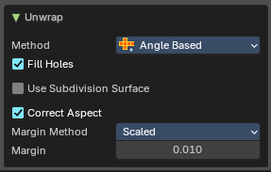
Unwrap ABF and Unwrap LSCM shares the same Last Operator.

Method
Method is a drop down box where you can choose between Unwrap method Angle Based and Conformal.

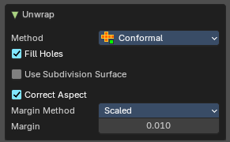
Fill Holes
Fill holes in the mesh before unwrapping.

Use Subdivision Surface
Unwraps an existing Subdivision Modifier. You need to add a Subdivision Modifier first.

Correct Aspect
Take the Image Aspect Ratio into account.

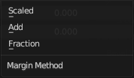
Margin Method

Scaled
Use the scale of existing UV to multiply margin.

Add
Just add the margin and ignore any existing UV.

Fraction
Specify a precise fraction of specific UV.

Margin
The distance between the single UV patches.

Method Minimum Stretch
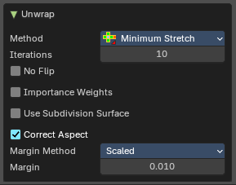

Iterations
Number of iterations.

No Flip
Prevent flipping UV's

Importance Weight
Take per vertex importance weights into account.

Use Subdivision Surface
Unwraps an existing Subdivision Modifier. You need to add a Subdivision Modifier first.

Correct Aspect
Take the Image Aspect Ratio into account.

Margin Method

Scaled
Use the scale of existing UV to multiply margin.

Add
Just add the margin and ignore any existing UV.

Fraction
Specify a precise fraction of specific UV.

Margin
The distance between the single UV patches.

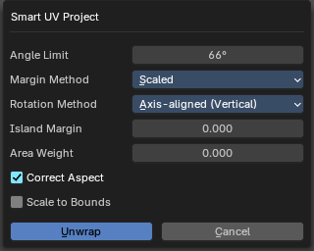
Smart UV Project
Smart UV Project projects the UV mapping from different angles.

Smart UV Project Settings dialogue

Angle Limit
The Angle Limit defines after which angle the mapping happens from the next side. With an angle of 66 you have around six sides to map from. The calculation is 360/66.

Margin Method

Scaled
Use the scale of existing UV to multiply margin.

Add
Just add the margin and ignore any existing UV.

Fraction
Specify a precise fraction of specific UV.

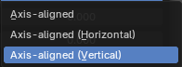
Rotation Method
How to rotate islands.

Island Margin
Island Margin defines the distance between the UV patches.

Area Weight
Weight Projection Vector by faces with larger areas.

Correct Aspect
Take the Image Aspect Ratio into account.

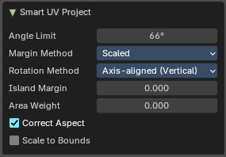
Last Operator Smart UV Project
The Last Operator for Smart UV Project contains the same settings than the Smart UV Project Settings dialogue.

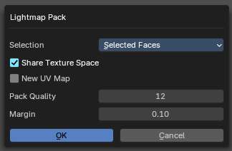
Lightmap Pack
Lightmap Pack maps each face individually, and puts the result into the UV space. Without margin.
Lightmap Pack has no Last Operator.

Settings

Selection
Selection is a drop-down box where you can choose what will be packed.

Share Tex Space
Map all objects into one lightmap.

New UV Map
Create a new UV map for every new mesh.

Pack Quality
The pack quality.

Margin
The distance between the single UV patches.

Follow Active Quads
Follow Active quads maps UV coordinates starting from an active face, and maps all adjacent faces in quad shape then. This way you can for example unwrap a pipe or a road. You first need to have a face selected. Then select everything. And then click at Follow Active Quads.

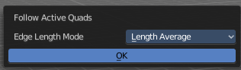
Settings

Edge Length Mode
Edge Length Mode is a drop-down box where you can choose the Length method.

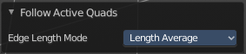
Last Operator Follow Active Quads
The Last Operator contains the same settings than the Settings dialogue.

Cube Projection
Cube Projection maps the mesh from six sides, means cubic.

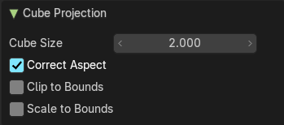
Last Operator Cube Projection

Cube Size
Cube Size defines the size of the UV mesh in the UV space.

Correct Aspect
Take Image Aspect ratio into account.

Clip to Bounds
Clip UV Coordinates to bounds after unwrapping.

Scale to Bounds
Scale UV Coordinates to bounds after unwrapping.

Cylinder Projection
Cylinder Projection tries to map the geometry cylindric.

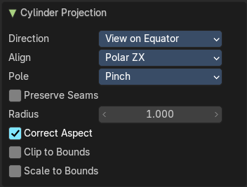
Last Operator Cylinder Projection

Direction
Direction is a drop-down box where you can choose in which direction the cylindric projection will be mapped.

Align
Align is a drop-down box where you can choose the Align method.

Pole
How to handle the faces at the poles.

Preserve Seams
Separate Projections by islands isolated by seams.

Radius
Radius defines the Polar size of the UV mesh in the UV space.

Correct Aspect
Take Image Aspect ratio into account.

Clip to Bounds
Clip UV Coordinates to bounds after unwrapping.

Scale to Bounds
Scale UV Coordinates to bounds after unwrapping.

Sphere Projection
Sphere Projection tries to map the geometry spherical.

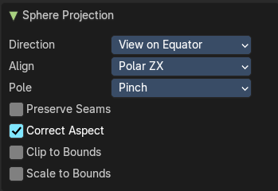
Last Operator Sphere Projection

Direction
Direction is a drop-down box where you can choose in which direction the spherical projection will be mapped.

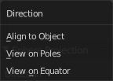
Align
Align is a drop-down box where you can choose the Align method.

Pole
How to handle the faces at the poles.

Preserve Seams
Separate Projections by islands isolated by seams.

Correct Aspect
Take Image Aspect ratio into account.

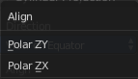
Clip to Bounds
Clip UV Coordinates to bounds after unwrapping.

Scale to Bounds
Scale UV Coordinates to bounds after unwrapping.

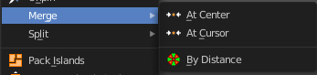
Merge

At Center
Merges the selected vertices at the center point.

At Cursor
Merges the selected vertices not only at the cursor. The last operator provides you with four methods.

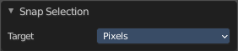
Last Operator Snap Selection

Target
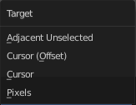
The snapping target. Snap and merge at the following locations.
Adjacent unselected
Cursor ( Offset)
Cursor
Pixels

By Distance
Merge UV vertices when they are below a merge distance.

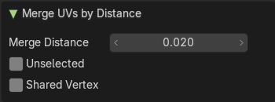
Last Operator Merge UV's by Distance

Merge Distance
The merge distance below the vertices gets merged.

Unselected
Merge selected vertices to unselected vertices.

Shared Vertex
Weld UV’s based on shared vertices.

Split Selection
Splits the selected geometry. UV Sync Selection needs to be off.

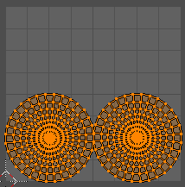
Pack Islands
Pack Islands tries to pack the selected UV geometry as close together as possible. Without to waste too much empty space.
Note that the algorithm fails at round geometry. It calculates with rectangle shapes.

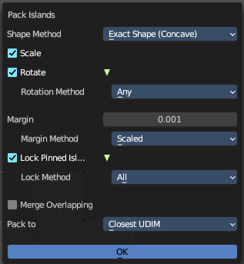
Pack Islands Popup
When you click the operator then you will see a popup panel where you can adjust the further settings.

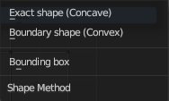
Shape Method
How the islands are packed.

Exact Shape (Concave)
Use exact geometry.

Boundary Shape (Convex)
Use a convex hull.

Bounding Box
Use a bounding box.

Scale
Scale islands to fill the unit square.

Rotate
Rotate islands to improve layout.

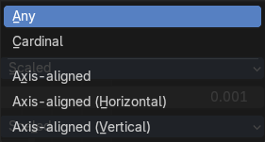
Rotation Method
The rotation method.

Any
Any angle is allowed for rotation.

Cardinal
Only 90 degrees rotation are allowed

Axis - aligned
Rotate to a minimal rectangle. Either horizontal or vertical towards the shortest distance.

Axis - aligned ( Horizontal )
Rotate to a minimal rectangle. Horizontal.

Axis - aligned ( Vertical )
Rotate to a minimal rectangle. Vertical.

Margin
Adjust the margin amound.

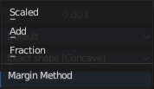
Margin Method
What method to use for the margin. UV patches needs a margin between the single patches. So that the pixels of the texture doesn't bleed into other areas.

Scaled
Use scale of existing UV's to multiply margin.

Add
Just add the margin. And don't use the UV scale for calculation too.

Fraction
Specify a precise fraction of final UV output.

Lock Pinned Islands
Constrain islands that contains any pinned UV's

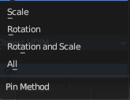
Lock Method
How to deal with pinned UV islands.

Scale
Pinned islands won't scale.

Rotation
Pinned islands won't rotate.

Rotation and Scale
Pinned islands won't scale and rotate

All
Pinned islands will remain at their initial position and are locked in place.

Merge Overlapping
Overlapping islands stick together.

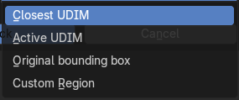
Pack To

Closest Udim
Pack islands to closest UDIM image tile

Active Udim
Pack islands to active UDIM image tile, or to the UDIM grid tile where the 2d cursor is located.

Original Bounding Box
Pack to the starting bounding box of islands.

Custom Region
Pack to custom region.

Average Island Scale
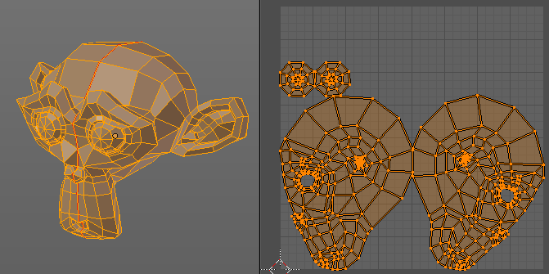
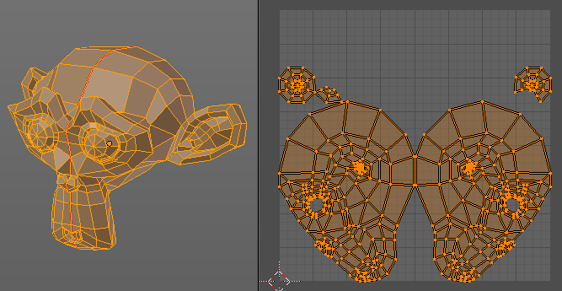
Scales the selected UV geometry to have the same relative size than the rest of the mesh. So that the texels at the mesh have roughly the same size everywhere.

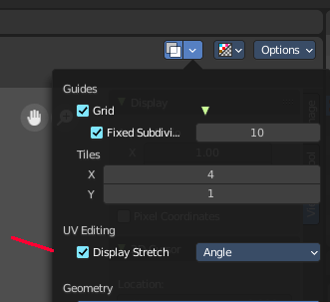
Minimize Stretch
You might end in a UV mapping result that still shows unwanted distortions here and there. For example when you UV map a human face. Minimize Stretch tries to minimize this stretching effects in the UV patches.
To view stretched areas at your UV patches, tick Display Stretch in the Overlays panel, and switch from Angle to Area. Then a stretch mask gets displayed. The color range goes from blue to green to red, where blue is minimal stretch and red is maximal stretch.
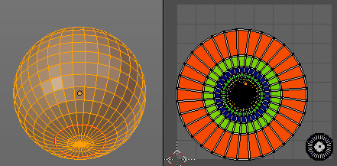
Let's explain it with an example. A sphere where the cut is nearly at the pole. And UV mapped with Angle Based. The result will of course show heavy stretched areas.

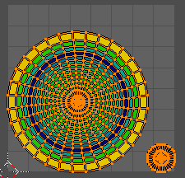
Note that the UV geometry must be selected in the UV Image editor. Now let's use the Minimize stretch tool. The algorithm now first tries its best to find the best fitting result that shows fewest stretching across the overall UV geometry.

The header shows a help text while the algorithm works. The Blend factor is the value between the original unwrapped UV mesh, and the maximum minimized stretch. You can set this value manually by using the scroll wheel at your mouse, or with the + and - keys.
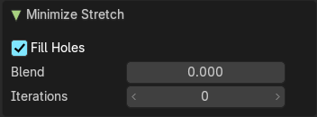

Last Operator Minimize Stretch

Fill Holes
Fill holes virtually fills holes before unwrapping to avoid overlapping and to preserve the geometry.

Blend
The Blend factor is the value between the original and the maximum minimized stretch.

Iterations
Number of iterations for the Minimize stretch algorithm.

Stitch
Stitch tries to union UV patches along the selected edges or vertices.
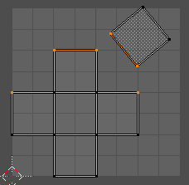
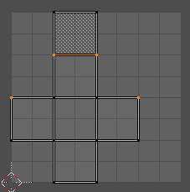

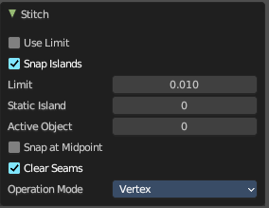
Last Operator Stitch
This last operator appears in the 3D view.

Use Limit
Just snap when the elements are below a given distance.

Snap Island
Snap the whole UV patch, or just the selected edge(s)/vertices

Limit
The limit distance for Use Limit.

Static Island
Adjust which island stays in place when stitching.

Active Object
Index of the active object.

Snap at Midpoint
Snap at the center point of the two elements instead the first to the last.

Clear Seams
Unmarks seams when stitching.

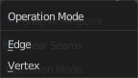
Operation Mode
The operation mode. Calculate with Edges or Vertices.

Mark Seam
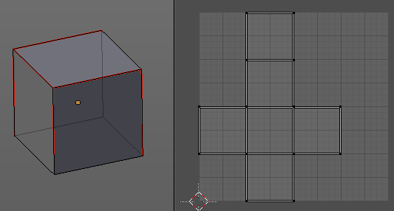
The unwrap algorithms Angle based and Conformal requires to have edges marked as seams. Think of it as a cutting pattern for a trouser for example. Such a trouser is also made of fabric patterns.
Same goes for the UV patches when you use Angle based or conformal unwrapping. You need to cut your mesh into parts and mark edges as seams, so that the algorithm knows where the seams are.
Mark seam marks the currently selected edge(s) as a seam. Seam edges will be displayed as red in the 3D viewport. But not in the UV Image Editor. The UV patches represents the seams.
You need to unwrap the mesh again when you want to apply changes by the new marked seams.

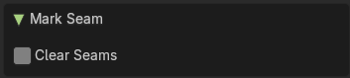
Last Operator Mark Seam

Clear
Clears the seam instead of marking it.

Clear Seam
Clear seam removes the seam from the currently selected edge(s) in the 3D view.

Seams from Islands
Unwrapping creates the UV geometry from the 3D object. You mark the seams, then you click at unwrap, and the UV mesh gets created.
Mark Seams from islands goes the other way around for marking seams. It creates the seams at the mesh object in the 3D view from the UV geometry in the UV Image Editor.
A use case is when you import meshes. Then you usually just have the UV patches in the UV Image editor. And when you want to modify the UV's further, then you need the seams at the mesh.

Align/Arrange Islands
Provides a unified interface for aligning, distributing, and organizing UV islands based on axis, order, and spacing. Ideal for texture atlases, modular layouts, and precision packing.
Aligns selected UV islands along a chosen axis.

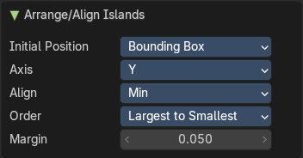
Last Operator Arrange/Align Islands

Initial Position
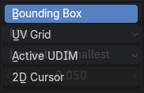
Defines how the alignment reference is calculated for each island. This determines where each island "snaps" during alignment—e.g., top edge, center, or bottom edge.

Bounding Box
Uses the outer bounds of each island.

UV Grid
Aligns islands relative to the overall UV grid (typically 0–1 space).

Active UDIM
Uses the currently active UDIM tile as the reference.

2D Cursor
Aligns islands based on the position of the UV Editor’s 2D cursor.

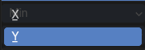
Axis
Specifies the direction along which islands will be aligned. X or Y. Useful for stacking islands top-to-bottom or side-by-side.

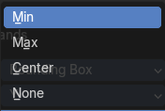
Align
Controls which part of the island is aligned to the axis. This affects how islands are visually positioned relative to each other.

Min
Aligns the minimum bound (e.g., bottom or left edge)

Center
Aligns the center of the island

Max
Aligns the maximum bound (e.g., top or right edge)

None
Preserves the island alignment.

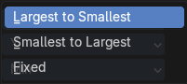
Order
Determines the sequence in which islands are arranged.

Margin
Sets the spacing between islands after alignment. Adds consistent padding between islands to avoid texture bleeding or overlap.

Value
Float input (e.g., 0.050)

Set User Region
Defines a custom region within the UV Editor viewport, allowing you to isolate, focus, or constrain operations to a specific area of the UV space.

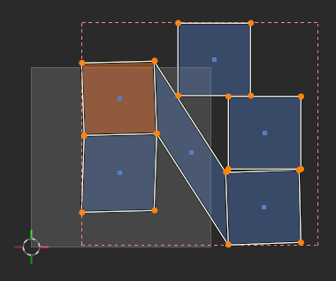
Use
An example is for Packing Islands: Limit packing to a specific region (e.g. top-right quadrant of the UV space). This can be used to constrain packing or alignment operations.

This can also serve as a reference zone for manual editing or snapping.

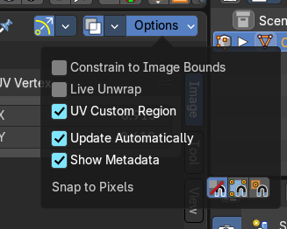
To toggle visibility after defining it manually, use the Options drop down to the top right of the header.

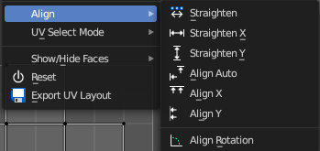
Align submenu
Align the selected geometry. Affected are the vertices.

Straighten
Straightens the selected geometry in both directions, X and Y axis.

Straighten X
Straightens the selected geometry along the X axis.

Straighten Y
Straightens the selected geometry along the Y axis.

Align Auto
Aligns the selection. The align axis gets chosen from the selection itself. When it's higher than tall, then it aligns along the Y axis. When it's taller than high, then it aligns along the X axis.
The align point is the pivot of the selection.

Align X
Aligns the selection along the X axis. The align point is the pivot of the selection.

Align Y
Aligns the selection along the Y axis. The align point is the pivot of the selection.

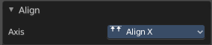
Last operator Align
The Last operator Align unions all the single straighten and align actions in one operator.

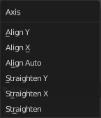
Axis
Lists the straighten and align methods again.

Align Rotation
Aligns the selected geometry horizontally or vertically. It aligns to the closest angle.

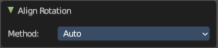
Last operator Align Rotation

Method

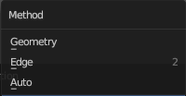
Geometry
Aligns the whole geometry.

Edge
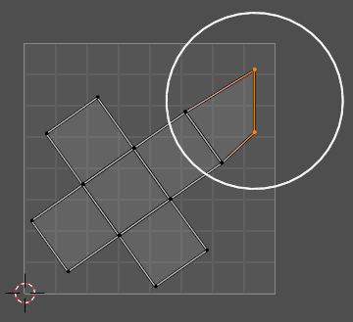
Aligns the geometry along the selected edge.

Auto
Checks for selection, and aligns then either the whole geometry or by the selected edge.

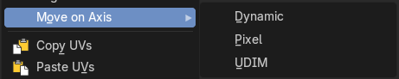
Move on Axis submenu

Dynamic
Move UV’s on an axis dynamically

Pixel
Move UV’s on an axis by pixel

UDIM
Move UV’s on an axis by UDIM tile.

Copy UV
Copy selected UV vertices.

Paste UV
Pastes copied UV vertices.

Show / Hide Faces submenu
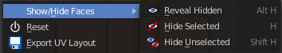
Show or hide faces. This happens in both, the 3D View and the UV editor.

Reveal Hidden
Makes all geometry visible again.

Hide Selected
Hides the selected geometry.

Hide Unselected
Hides the not selected geometry. The selected geometry stays visible.

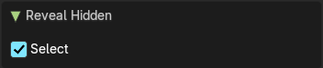
Last Operator Reveal Hidden / Hide Selected

Select
Define if the selected or the unselected elements gets hidden or revealed.

Reset
Resets the UV projection. Every single face gets fit into the UV space range of 0/1

Export UV Layout
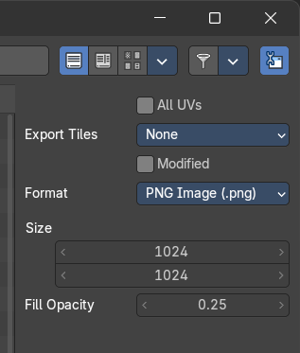
Export the UV layout to an image, so that you can use it as a mask to build your texture in your favorite image editing software like Photoshop. It will open a file dialog, where you can define further export settings down left.
In the export dialog you will see export settings at the right side

All UV's
Export all UV's, not just the visible ones.

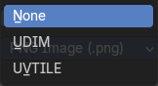
Export Tiles
If to export UDIM tiles.

Modified
Export UV's from the modified mesh.

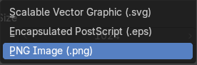
Format
Choose the export format.

Size
Define the size of the image.

Fill Opacity
How opaque the wire frame lines are.

